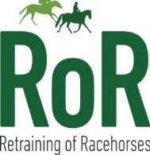

Unaffiliated Eventing Series 2025 - 100cm

Horse | Rider | Points | Placing
Powder King | Lucy Bell | 12 | 1st

